MATH STUDENT RESPONSE SHEET

Name of Open Response: Hike Student Name____________________

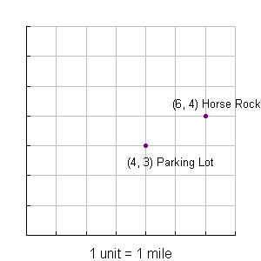
Tom and Joe are going hiking. Tom hikes from the parking lot to Horse Rock, and Joe stays at the parking lot.

- Both hikers have portable radios that have a maximum
range of two miles. Can Tom and Joe get in contact with
each other when Tom reaches Horse Rock?
Explain your answer.

- Later that day Joe starts hiking. He meets Tom for lunch
at the halfway point between the parking lot and Horse
Rock. What are the coordinates of their grid location for
lunch? Show your work.

Scoring Guide for
Score | Description
4
3
2
1
0 | Response is totally incorrect or irrelevant.
Blank | No response.

